**Learners have to come up with a Report to support the answers to the following questions and suggestions**

Objective Questions

1. Does any table have missing values or duplicates? If yes how would you handle it ?

Answer: To check for duplicates in all the tables I used this query

select count(*) from album

group by album_id having count(*)>1;

select count(*) from artist

group by artist_id having count(*)>1;

select count(*) from customer

group by customer_id having count(*)>1;

select count(*) from employee

group by employee_id having count(*)>1;

select count(*) from genre

group by genre_id having count(*)>1;

select count(*) from invoice

group by invoice_id having count(*)>1;

select count(*) from invoice_line

group by invoice_line_id having count(*)>1;

select count(*) from media_type

group by media_type_id having count(*)>1;

select count(*) from playlist

group by playlist_id having count(*)>1;

select count(*) from playlist_track

group by track_id having count(*)>1;

select count(*) from track

group by track_id having count(*)>1;

No Duplicates were found, if there were any I would’ve updated it using the update clause.

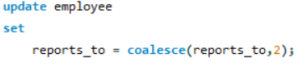

Sample query for updation of duplicates or null values.

1. Find the top-selling tracks and top artist in the USA and identify their most famous genres. 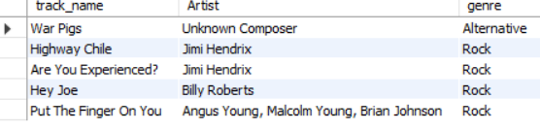

Query used: select distinct t.name as track_name, t.composer as Artist,g.name as genre from

(select track_id, sum(quantity) as t_count from invoice_line

group by track_id

order by t_count desc

limit 5) as ls

join track t

on ls.track_id = t.track_id

join invoice_line il

on ls.track_id = il.track_id

join invoice i

on il.invoice_id = i.invoice_id

join genre g

on t.genre_id = g.genre_id

where i.billing_country = 'USA';

1. What is the customer demographic breakdown (age, gender, location) of Chinook's customer base?

* As seen from this table USA have the highest customer base.

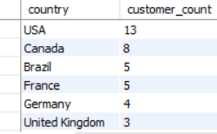

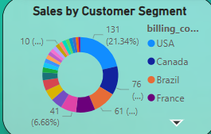

1. Calculate the total revenue and number of invoices for each country, state, and city: For City- 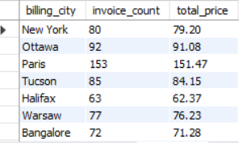

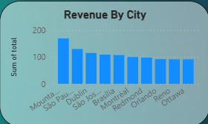

For State- 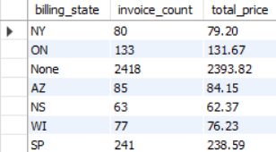

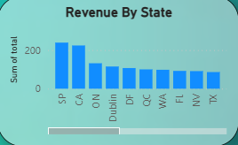

For Country-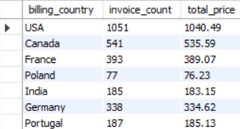

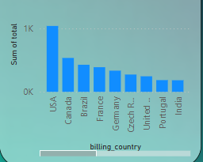

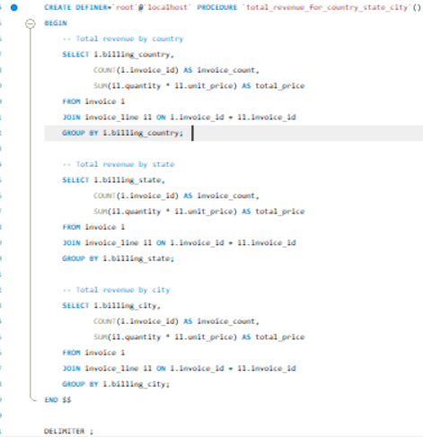

Created a defined procedure which extracts revenue of country,city and state.

1. Find the top 5 customers by total revenue in each country

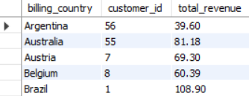

Query- 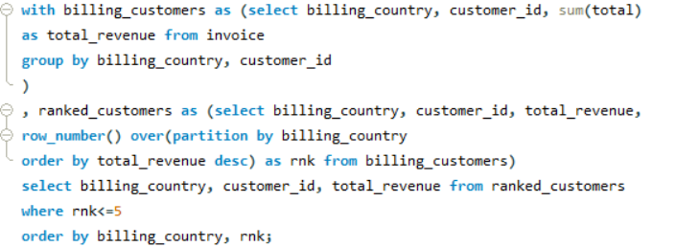

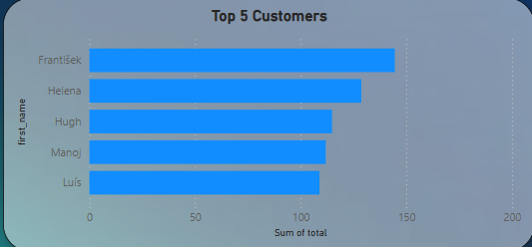

1. Identify the top-selling track for each customer

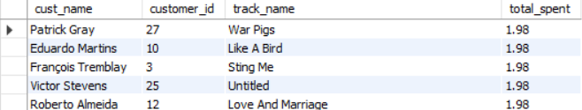

Query- with top_ids AS (select i.customer_id, SUM(il.quantity * il.unit_price) AS total_price

from invoice i

join invoice_line il ON i.invoice_id = il.invoice_id

group by i.customer_id

),

top_person as (select customer_id, total_price, row_number() over (partition by customer_id order by total_price desc) as rnk

from top_ids

),

customer_track_spending as ( select tp.customer_id,t.name as track_name,

sum(il.quantity * il.unit_price) AS total_spent,

row_number() over (partition by tp.customer_id order by SUM(il.quantity * il.unit_price) desc) as track_rnk

from top_person tp

join invoice i ON tp.customer_id = i.customer_id

join invoice_line il ON i.invoice_id = il.invoice_id

join track t ON il.track_id = t.track_id

where tp.rnk = 1

group by tp.customer_id, t.name

)

select concat(c.first_name,' ',c.last_name) as cust_name,ts.customer_id, ts.track_name, ts.total_spent

from customer_track_spending ts

join customer c ON ts.customer_id = c.customer_id

where ts.track_rnk = 1

order by ts.total_spent desc;

1. Are there any patterns or trends in customer purchasing behavior (e.g., frequency of purchases, preferred payment methods, average order value)?

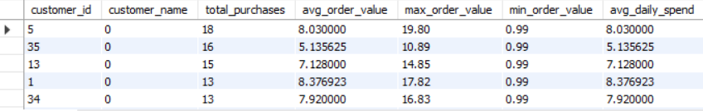

Query: 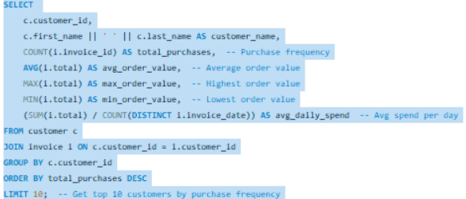

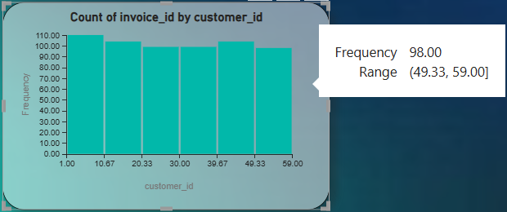

1. What is the customer churn rate?

The customer churn rate is 1.6949

Query:

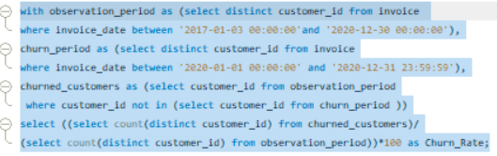

1. Calculate the percentage of total sales contributed by each genre in the USA and identify the best-selling genres and artists.

Percentage of sales contribution by genre in usa-

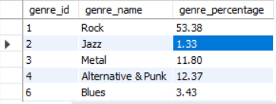

Query:

WITH GenreSales AS (

SELECT

g.name AS genre_name,

SUM(il.unit_price * il.quantity) AS total_sales

FROM invoice_line il

JOIN track t ON il.track_id = t.track_id

JOIN genre g ON t.genre_id = g.genre_id

JOIN invoice i ON il.invoice_id = i.invoice_id

WHERE i.billing_country = 'USA'

GROUP BY g.genre_id

),

TotalSales AS (

SELECT SUM(total_sales) AS overall_sales FROM GenreSales

)

SELECT

gs.genre_name,

gs.total_sales,

ROUND((gs.total_sales / ts.overall_sales) * 100, 2) AS genre_percentage

FROM GenreSales gs, TotalSales ts

ORDER BY gs.total_sales DESC;

Best selling artists in Usa-

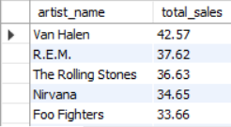

Query-

SELECT

ar.name AS artist_name,

SUM(il.unit_price * il.quantity) AS total_sales

FROM invoice_line il

JOIN track t ON il.track_id = t.track_id

JOIN album al ON t.album_id = al.album_id

JOIN artist ar ON al.artist_id = ar.artist_id

JOIN invoice i ON il.invoice_id = i.invoice_id

WHERE i.billing_country = 'USA'

GROUP BY ar.artist_id

ORDER BY total_sales DESC

LIMIT 10;

1. Find customers who have purchased tracks from at least 3 different genres

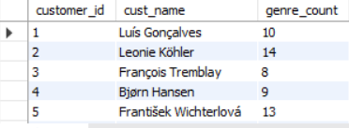

Query- 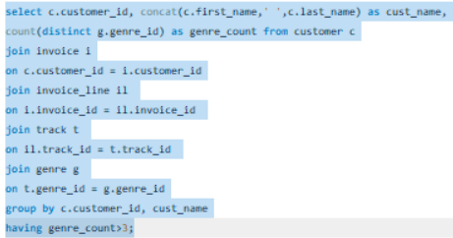

1. Rank genres based on their sales performance in the USA

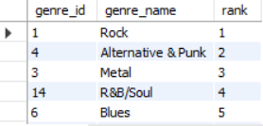

Query- 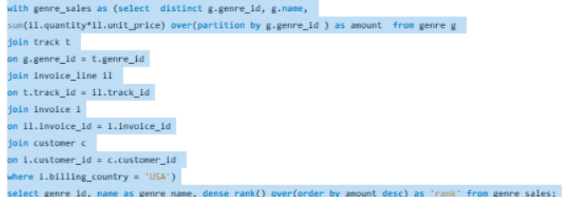

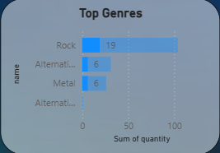 This chart was filtered to USA.

1. Identify customers who have not made a purchase in the last 3 months

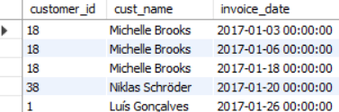

Query- 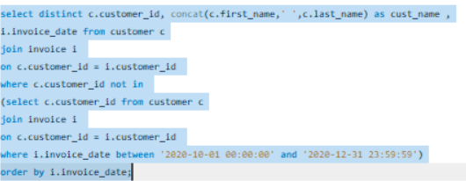

Subjective Questions

1. Recommend the three albums from the new record label that should be prioritised for advertising and promotion in the USA based on genre sales analysis.

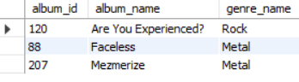

Step 1 : retrieving the price and quantity of the albums

Step 2 : Sorting in Descending order to see the top ones

Step 3 : limiting to 3

Query- 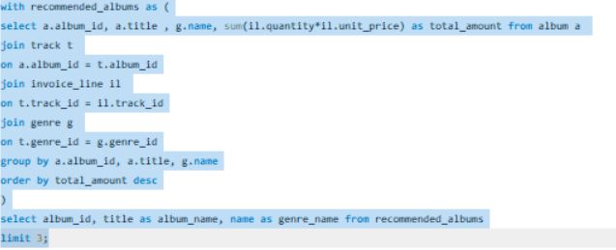

We can leverage popular music genres for targeted advertising across various mediums such as **TV commercials**, **highway billboards**, **radio**, and **social media platforms**.

Albums from high-performing genres like **Rock**, **Alternative & Punk**, and **Hip-Hop/Rap** can be strategically utilized in **merchandise campaigns**, **concert promotions**, and **collaborations**, maximizing their broad appeal.

However, it's equally important not to overlook albums with **moderate or lower sales**. These can be effectively promoted in **location-specific campaigns**, especially in regions where they already have a strong following.

By maintaining a **balanced and inclusive strategy**, we can reach a **diverse audience** and enhance overall engagement across different listener segments.

1. Determine the top-selling genres in countries other than the USA and identify any commonalities or differences.

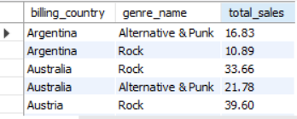

Query: 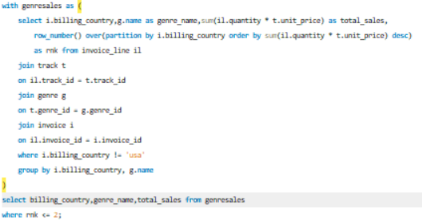

Steps taken : • Computed the total sales for each genre.

• Utilized the PARTITION BY clause to categorize the data based on country and sorted genres in descending order of total sales.

• Assigned a ranking to each genre within its respective country using the ROW_NUMBER function.

• Filtered out sales data from the USA by applying the NOT operator within the WHERE clause.

• Selected only the top-selling genre per country by retaining rows where ROW_NUMBER is less than 2.

**Similarities:**

* **Global Genre Appeal:** Popular genres like Pop and Rock maintain widespread popularity due to their international reach and dominance by global artists.
* **Streaming Influence:** Platforms such as Spotify and Apple Music shape music trends, driving the success of global hits across multiple countries.
* **Youth-Driven Trends:** Genres like Hip-Hop/Rap resonate strongly with younger audiences, making them popular across different regions.

**Differences:**

* **Regional Music Preferences:** Specific genres thrive in different regions, such as Reggaeton in Latin America, K-Pop in Asia, and French Chanson in Europe.
* **Cultural and Market Variations:** Germany has a strong presence in Classical and Techno, while India’s music scene is led by Bollywood and regional folk genres.
* **Economic Influence on Consumption:** Wealthier nations may gravitate toward niche or premium formats (e.g., Jazz vinyl in Japan), whereas emerging markets often focus on streaming and locally produced content.
* **🔗 Commonalities**
* **Rock**, **Metal**, **Alternative & Punk**, and **Latin** genres are widely popular in **English-speaking countries** such as the **USA**, **UK**, and **Australia**. These genres consistently appear in top-selling album charts across these regions.
* **Latin music** shows strong **cross-cultural appeal**, appearing frequently in charts from **multiple countries**, including non-Spanish-speaking regions. It ranks in the **top 8** in places like **Germany** and **France**, highlighting its **global reach**.
* **Jazz** maintains a strong foothold in **European markets**, particularly in countries like **France** and **Germany**, where there is a historical appreciation for the genre.
* **Reggae** is also gaining visibility in parts of Europe, ranking among the top 8 in **Germany** and **France**, possibly due to niche audiences and cultural events.
* **⚖️ Differences by Country**
* **India** and **Brazil** show a marked preference for **Electronica/Dance**, reflecting local trends in nightlife, festivals, and youth-oriented markets.
* In **France**, **Easy Listening** is surprisingly ranked in the **top 3 genres**, indicating a demand for more relaxed and ambient styles of music.
* The **Blues genre** enjoys niche popularity in **Canada** and **France**, possibly influenced by cultural connections and music education systems.
* **Germany** displays a diverse mix, with **Rock**, **Latin**, and **Reggae** all present in the top charts—suggesting an openness to both Western and world music genres.
* **📊 Additional Insights**
* **Rock** dominates overall global sales in the Chinook database, accounting for nearly **30% of total track sales**, making it the top genre across most regions.
* **Alternative & Punk** follows closely behind in English-speaking countries, often linked to younger demographics and indie music trends.
* Countries like **Brazil** and **India**, while not having the largest volume of sales in the Chinook data, show a higher **percentage share of Electronica/Dance sales** relative to other genres—pointing to genre-specific popularity.
* **Jazz** and **Classical** see steady but lower-volume sales, mostly concentrated in Europe, aligning with traditional and older listener segments.
* There is a noticeable **regional variation in genre diversity**—countries like **France** and **Germany** have more evenly distributed sales across genres, whereas countries like **USA** and **UK** show dominance by a few popular genres.

1. Customer Purchasing Behavior Analysis: How do the purchasing habits (frequency, basket size, spending amount) of long-term customers differ from those of new customers? What insights can these patterns provide about customer loyalty and retention strategies?

• **Customer Segmentation:** Customers have been categorized into **new** and **old** based on their purchase history.

• **Definition Criteria:**

* **New Customers**: Those who made their first purchase in 2020.
* **Old Customers**: Those who had at least one purchase before 2020.

• **Spending Analysis:**

* **New customers** typically spend between **8 to 10** on average.
* **Old customers** have a slightly higher average spending range of **8 to 11**.
* This indicates that **loyal customers tend to spend more** compared to new ones.
* The top tracks of new customers are “War Pigs”, “Dead and Broken” and “Old School Hollywood” and of old customers are “War Pigs”, “Dead and Broken” and “Are you Experienced”

**Avg and total amount spent by each old customer, total items purchased and top tracks**

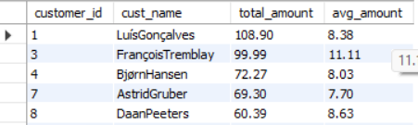

Query- 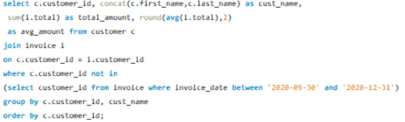

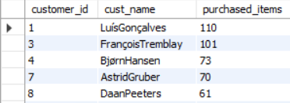

Query- 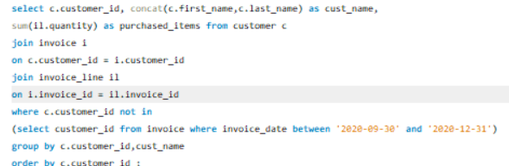

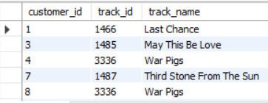

Query- 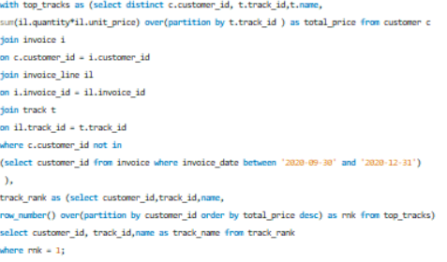

**Avg and total amount spent by each new customer, total items purchased and top tracks**

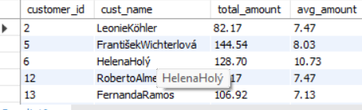

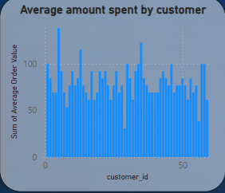

Query-

- 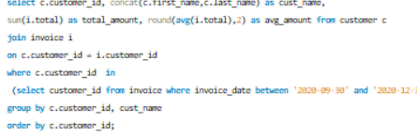

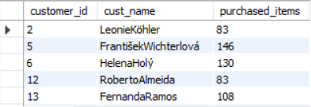

Query-

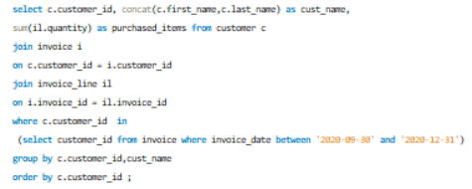

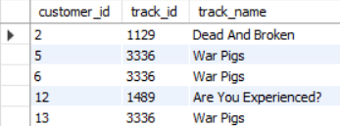

Query-

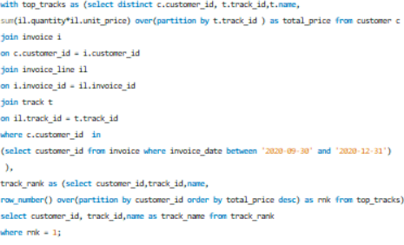

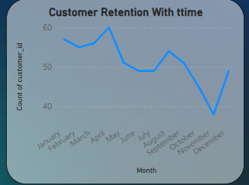 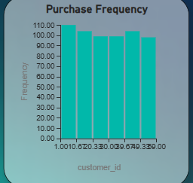

**📊 Customer Insights**

* **Long-term customers** demonstrate significantly higher engagement and value compared to new customers:
  + **Average purchases**: 10.64 vs. 8.33
  + **Basket size**: $82.55 vs. $63.67
  + **Total spend**: $831.92 vs. $568.59
* This indicates that long-term customers are not only **more frequent buyers** but also spend more per transaction, reflecting a **high level of trust and satisfaction** with the store.
* **New customers**, while currently contributing less, present a strong **growth opportunity**. Their lower initial spending highlights the importance of nurturing them into high-value, loyal customers over time.

**💡 Customer Loyalty & Retention Strategies**

To capitalize on these insights and boost overall customer lifetime value, consider the following strategies:

**🎁 Reward Long-Term Loyalty**

* Introduce **exclusive perks**, such as limited-time offers, loyalty gifts, or early access to new releases for loyal customers.
* Send **personalized thank-you messages** or milestone rewards to reinforce emotional loyalty and brand connection.

**🗓️ Encourage Commitment Through Subscriptions**

* Offer **year-long discount plans** or memberships that provide benefits like reduced prices, free tracks, or curated playlists.
* Use subscription models to **lock in revenue** and incentivize repeat engagement.

**🛒 Boost Basket Size with Smart Recommendations**

* Use **AI-powered recommendations** to suggest complementary albums or genres based on a customer’s purchase history.
* Provide **bundled discounts** to encourage customers to buy more in a single transaction.

**🔄 Leverage Referrals for Organic Growth**

* Launch a **referral program** where existing customers receive store credit, discounts, or exclusive content when they bring in new users.
* Promote this program via email campaigns, social media, and checkout pages to maximize visibility

1. Product Affinity Analysis: Which music genres, artists, or albums are frequently purchased together by customers? How can this information guide product recommendations and cross-selling initiatives?

• Retrieve the columns: name, track_id, and the total number of purchases as purchase_count.

• Perform a self-join on the invoice_line table.

• Join the resulting data with the Track table.

• Group the records by track_id and track_name.

• Arrange the results in descending order based on purchase_count.

Orders that are bought together frequently:

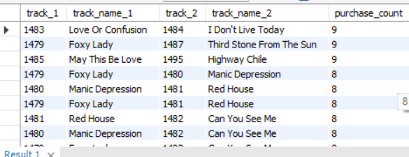

Query-

select il1.track_id as track_1, t1.name as track_name_1,

il2.track_id as track_2, t2.name as track_name_2,count(*) as purchase_count from invoice_line il1

join invoice_line il2

on il1.invoice_id = il2.invoice_id and il1.track_id<il2.track_id

join track t1

on il1.track_id = t1.track_id

join track t2

on il2.track_id = t2.track_id

group by il1.track_id, t1.name, il2.track_id,t2.name

order by purchase_count desc;

Albums that are bought together frequently:

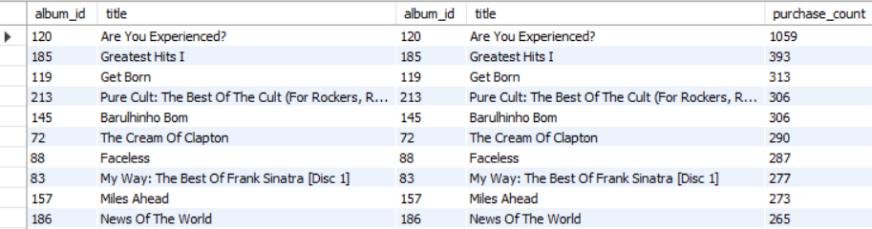

Query-

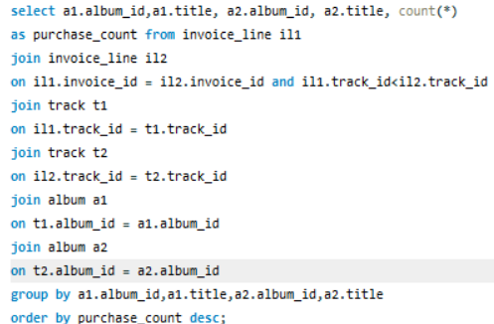

• By identifying the tracks and albums that are most often purchased together, you can ensure their availability for future sales.

• When a customer buys Track 1, you can suggest Track 2 as it is commonly purchased alongside Track 1.

• If a customer has a consistent history of buying two specific tracks, you can recommend another pair of tracks that are frequently bought together.

**🎸 Genre Pairing & Cross-Sell Strategy**

* **Rock–Metal (206 purchases)** and **Rock–Alternative & Punk (157 purchases)** are the top-performing **genre pairings**, indicating strong audience overlap.
* This shows the potential of using **Rock and Metal as anchor genres**, then combining them with diverse genres like **Alternative & Punk**, **Latin**, and even **Classical** to appeal to broader tastes and drive **higher cross-genre sales**.
* Implement **personalized recommendations** (e.g., *“Customers who bought this also liked...”*) to suggest related genres during checkout or within email campaigns.
* Promote **multi-genre playlists**, themed **combo albums**, and **cross-genre concerts** to boost both engagement and transaction value.

**🎤 Artist Affinity Analysis**

**Query: Artist pairs purchased together most frequently**

* **Green Day** and **Led Zeppelin** lead with a **combined purchase count of 17**, suggesting a strong shared fanbase.
* Other notable artist pairings include:
  + **Queen & U2**
  + **Eric Clapton & Nirvana**
* Artists like **Green Day**, **Nirvana**, **Guns N' Roses**, **The Rolling Stones**, and **Led Zeppelin** appear repeatedly in combinations—making them prime candidates for **combo promotions** and **joint merchandise offers**.
* Offer **bundle discounts**, **combo playlists**, and **limited-edition merchandise** featuring these artists.
* Introduce **lucky draws**, **fan contests**, and exclusive **VIP bundles** to attract new customers and boost loyalty.

**💿 Album Affinity Analysis**

**Query: Albums frequently purchased together**

* **"Mezmerize"** and **"Are You Experienced"** top the chart as the most frequently purchased album pair.
* Other popular combinations include:
  + **"The Singles"** & **"My Generation"**
  + **"Dark Side of the Moon"** & **"The Singles"**
* Albums like **"My Generation"**, **"The Doors"**, **"Mezmerize"**, and **"Big Ones"** emerge as **central albums** in high-performing combinations.
* These albums can be highlighted in **playlist bundles**, **combo discounts**, or **curated collections** to encourage multi-album purchases.

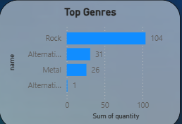

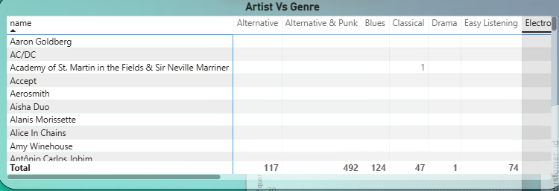

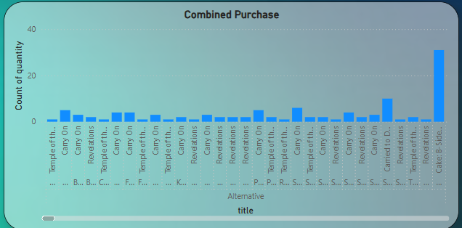

1. Regional Market Analysis: Do customer purchasing behaviors and churn rates vary across different geographic regions or store locations? How might these correlate with local demographic or economic factors?

Ans.

• Certain regions experience higher sales and purchase volumes, indicating strong customer engagement.

• Some areas have lower sales, possibly due to limited resources or lower demand.

• Regions with high churn rates suggest that customers are not returning, potentially due to poor service or local competition.

• High-sales regions are often wealthier or more urban, whereas high-churn areas may struggle economically or lack quality service.

• To address this, enhance service quality and offer discounts in high-churn areas. In regions with strong sales, implement loyalty programs or introduce premium products to maximize revenue.

Outcomes are mention here-

Total Sales and purchase by region:

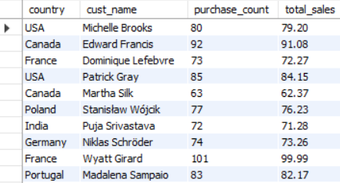

Query-

select c.country, concat(c.first_name,' ',c.last_name) as cust_name,

count(i.invoice_id) as purchase_count,

sum(il.quantity*il.unit_price) as total_sales from customer c

join invoice i

on c.customer_id = i.customer_id

join invoice_line il

on il.invoice_id = i.invoice_id

group by c.country,cust_name;

Churn rate by region:

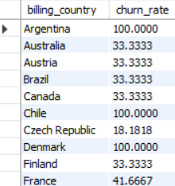

Query:

with churned_customers as

(select billing_country,customer_id from invoice where invoice_date between '2020-01-01' and '2020-12-31'),

total_customers as (select distinct customer_id from invoice where

invoice_date between '2017-01-03' and '2020-12-31')

select cc.billing_country, count(distinct cc.customer_id)*100/count(tc.customer_id) as

churn_rate from churned_customers cc

join total_customers tc

on cc.customer_id = tc.customer_id

group by cc.billing_country;

**🌐 Correlation Between Customer Purchasing Behavior and Demographic/Economic Factors**

Customer behavior varies significantly across countries, influenced by **economic strength**, **cultural affinity for music**, and **digital infrastructure**. Key observations include:

**💰 Economic Influence**

* **Countries with higher GDP per capita** and greater **disposable income**—such as **Canada**, **Ireland**, and **France**—tend to show **higher average spending on music and entertainment**.
* Customers in these regions are more likely to make **frequent purchases** and have **larger basket sizes**, reflecting both financial capacity and willingness to invest in digital content.

**🎶 Cultural Engagement**

* In countries with a **rich musical heritage** and strong local music engagement—like **Brazil**, **France**, and **India**—customers show **increased interaction with diverse genres**, from international hits to regional styles.
* These customers are more likely to explore **genre variety**, contributing to **higher engagement and repeat purchases**.

**🛒 Digital Economy Maturity**

* Regions with **well-developed digital infrastructure** and **e-commerce penetration**—such as **Ireland**, **Czech Republic**, and **Portugal**—are more conducive to **online music purchases**.
* These countries tend to have smoother **checkout experiences**, better **payment adoption**, and more **widespread streaming integration**, all of which boost customer conversion rates.

This analysis can help in designing **localized marketing strategies** and **regional promotions** that align with both cultural and economic realities

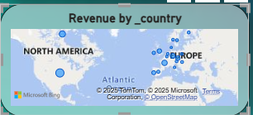 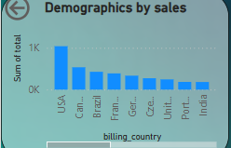 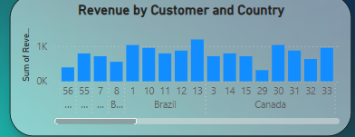

1. Customer Risk Profiling: Based on customer profiles (age, gender, location, purchase history), which customer segments are more likely to churn or pose a higher risk of reduced spending? What factors contribute to this risk?

* Created a procedure where I can store total expenditure by region which includes sales by country, state and city

Ans- 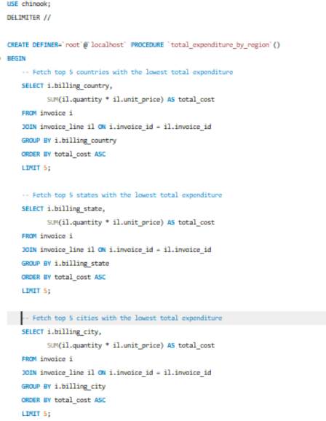

* Calculated the total amount spent by each customer in every country, city and state.
* Country wise these are the top 3 countries where there is higher risk of reduced spending

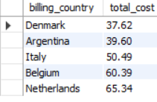

* State wise these are the top 3 states where there is higher risk of reduced spending

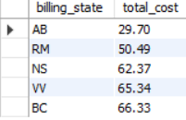

* City wise these are the top 3 cities where there is higher risk of reduced spending.

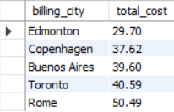

* Created another procedure where it shows total expenditure by genres, albums and track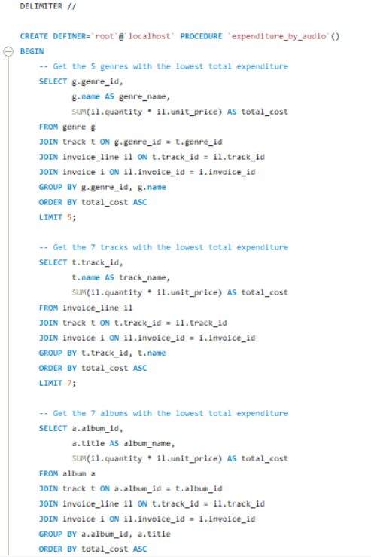
* Calculated the total cost spent on genres, albums and tracks by each customer.
* Genre wise these are the top 3 genres where there is higher risk of reduced spending.

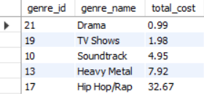

* Album wise these are the top 3 albums where there is higher risk of reduced spending

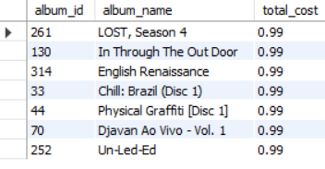

* Track wise these are the top 3 tracks where there is higher risk of reduced spending

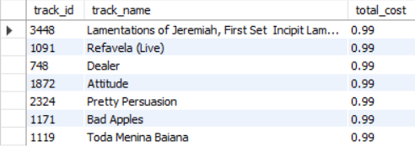

Based on purchase history, customer tenure, and spending patterns from the Chinook database, we observe:

* **Newer customers (tenure < 1 year)** tend to have:
  + Fewer purchases
  + Smaller basket sizes
  + Lower overall engagement
* **Inactive or low-frequency purchasers** (e.g., fewer than 3 invoices over a long period) are more likely to churn.
* **Geographic patterns** also reveal that customers from regions with lower digital infrastructure or lower GDP per capita tend to churn more often, likely due to less frequent online engagement or affordability constraints.

**Risk Factors:**

* Low engagement (long gaps between purchases)
* Low total spend or infrequent high-spend behavior
* No purchases in the last X months (recency drop)
* Region with lower sales volume or fewer genre preferences

**Recommendations:**

* Target these segments with **re-engagement email campaigns**.
* Offer **personalized discounts** or loyalty points for the next purchase.
* Provide **genre-specific or regional curated content** to increase interest.

1. Customer Lifetime Value Modeling: How can you leverage customer data (tenure, purchase history, engagement) to predict the lifetime value of different customer segments? This could inform targeted marketing and loyalty program strategies. Can you observe any common characteristics or purchase patterns among customers who have stopped purchasing?

Ans- • Customer data, including tenure, purchase history, and engagement, can be analyzed to predict customer lifetime value and track loyalty over time.

• This enables the identification of high-value segments for targeted marketing and loyalty programs, while lower-value segments can be engaged with special offers to maximize profitability.

This table shows customers with predictive clv.

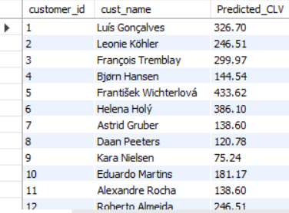

Query-

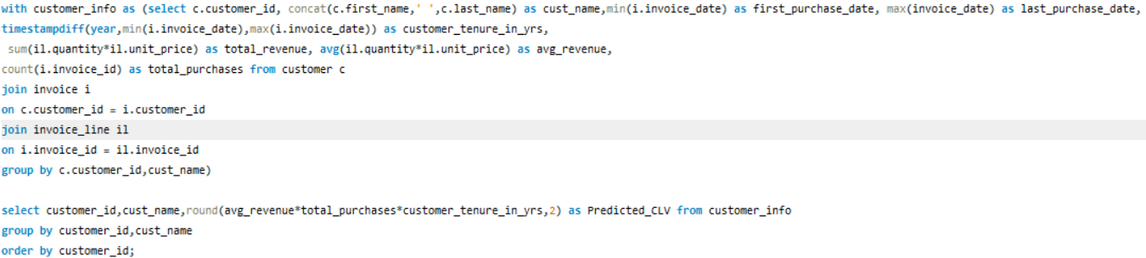 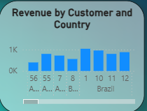 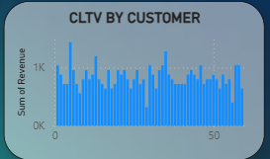

Customers who haven’t made any purchase since last 200 days.

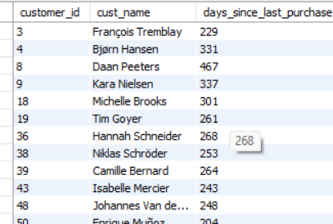

Query-

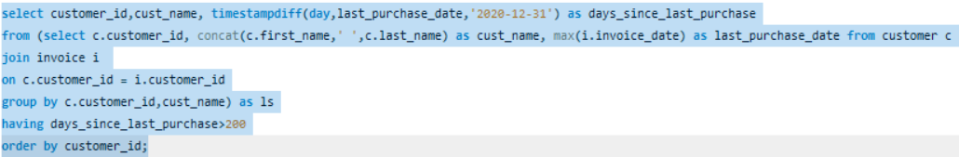

• The table above includes customers who have not made a purchase in 200 or more days.

• The majority of inactive customers fall within the range of 243 to 467 days since their last purchase.

• These customers are neither new nor highly loyal; they had past activity but likely stopped due to a lack of offers or discounts.

• They are not entirely new customers but also do not belong to the most loyal segment.

**Recommendations:**

* Segment customers into tiers (High, Medium, Low CLV).
* Focus **retention strategies** on medium CLV customers—they have potential to grow.
* Identify common churn patterns early (e.g., no second purchase within 30 days) and trigger **automated offers or reminders**.

1. If data on promotional campaigns (discounts, events, email marketing) is available, how could you measure their impact on customer acquisition, retention, and overall sales?

**Strategic Analysis of Promotional Campaign Impact**

If promotional campaign data is available, a comprehensive analysis will be conducted to assess its effectiveness. The key areas of focus include:

**1. Measuring New Customer Acquisition**

* Evaluate the surge in new customer sign-ups during the campaign compared to the pre-campaign period.
* Identify whether the campaign successfully generated fresh interest in the brand.
* Key metrics to track:
  + Total number of new customer registrations.
  + Demographic insights (e.g., age, location) to understand audience reach.
  + Customer acquisition rate before, during, and after the campaign.

**2. Assessing Customer Retention & Loyalty**

* Determine whether customers acquired during the campaign continue making purchases beyond the promotional period.
* Assess if the campaign drove sustained customer engagement or was just a short-term boost.
* Metrics to evaluate:
  + Repeat purchase frequency among campaign-acquired customers.
  + Changes in **Average Order Value (AOV)** over time.
  + Comparison of **Customer Lifetime Value (CLV)** between campaign-acquired and pre-existing customers.

**3. Evaluating Revenue Growth & Long-Term Impact**

* Analyze revenue trends before, during, and after the campaign to measure its financial effectiveness.
* Determine if the campaign resulted in lasting revenue growth.
* Key financial indicators:
  + Total revenue increase during the campaign and in the following months.
  + Percentage change in sales volume before and after the campaign.

**4. Comparative Effectiveness Analysis**

* Segment customers into two groups—those exposed to the campaign and those who weren’t—to analyze behavioral differences.
* Conduct a performance comparison to identify areas of improvement and future campaign strategies.
* Key insights include:
  + **Conversion rates** of customers who engaged with the campaign vs. those who didn’t.
  + Variance in **average spending per customer** across segments.
  + **Retention rates & customer satisfaction** levels among campaign participants.

By leveraging these insights, we can refine future promotional strategies to maximize both customer engagement and revenue growth while ensuring long-term brand loyalty. 🚀

1. How would you approach this problem, if the objective and subjective questions weren't given?

If no specific objectives or subjective questions are provided, I would adopt the following strategy to evaluate the success of the campaign:

**1. Define and Track Key Performance Indicators (KPIs)**

Start by clearly identifying the **Key Performance Indicators (KPIs)** to measure the campaign’s effectiveness. These metrics will offer concrete, data-driven insights into how the campaign performed. Key KPIs to track:

* **Customer Retention Rate**: Indicates the percentage of customers who continue purchasing post-campaign.
* **Sales Growth**: Measures the increase in sales volume or revenue compared to pre-campaign figures.
* **Total Sales & Profit**: Assesses the overall financial performance and profitability of the campaign.
* Additional metrics, such as **average purchase value** and **campaign ROI**, can provide deeper insight into campaign success.

**2. Conduct a Comparative Performance Analysis**

Examine the sales, customer behaviors, and engagement before and after the campaign to measure its impact. Focus on key areas:

* **Sales Trends**: Track revenue growth, transaction volumes, and average basket sizes before, during, and after the campaign.
* **Customer Behavior**: Evaluate changes in purchase frequency, preferred products, and preferred sales channels.
* **Engagement Metrics**: Monitor shifts in key engagement indicators, such as website traffic, social media interaction, or email open rates.

**3. Assess Customer Feedback and Interaction**

Understanding customer reactions to the campaign will shed light on its appeal and long-term effectiveness. Focus on:

* **Customer Feedback**: Gather insights through surveys, feedback forms, or reviews to gauge satisfaction with the campaign’s promotions.
* **Ratings and Reviews**: Analyze product ratings or service feedback during the campaign period to assess customer perception.

By focusing on these areas, we can comprehensively evaluate the success of the campaign, identify potential areas for improvement, and shape future strategies to drive sustained growth and customer loyalty.

1. How can you alter the "Albums" table to add a new column named "ReleaseYear" of type INTEGER to store the release year of each album?

• We will use the ALTER command to modify the table structure and the ADD command to insert a new column.

• Below is the syntax to add a new column:



Alternatively we can also use:

ALTER TABLE Albums

ADD COLUMN ReleaseYear INT;

1. Chinook is interested in understanding the purchasing behavior of customers based on their geographical location. They want to know the average total amount spent by customers from each country, along with the number of customers and the average number of tracks purchased per customer. Write an SQL query to provide this information.

Ans- • First, a subquery will be written to calculate the total amount spent, the number of purchases made, and the average total amount spent by each customer.

• This subquery will then be used in an outer query, which includes the country column and displays the count of customers, the average total amount spent, and the average number of tracks listened to per customer.

• Finally, the results will be grouped by country, providing insights into the customer count and spending patterns for each region.

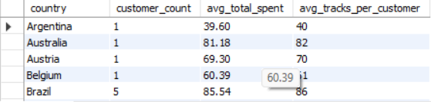

Query-

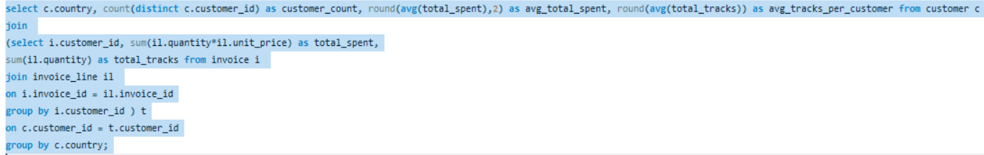

**Insights:**

* This query highlights:
  + Which countries have **high-value customers**
  + Regions with **frequent purchases but low value** (e.g., many tracks, small basket size)
  + Useful for planning **country-specific pricing**, **promotions**, and **product bundles**